SEC Form 4

FORM 4

Check this box if no longer subject to Section 16. Form 4 or Form 5 obligations may continue. See Instruction 1(b).

Check this box to indicate that a transaction was made pursuant to a contract, instruction or written plan for the purchase or sale of equity securities of the issuer that is intended to satisfy the affirmative defense conditions of Rule 10b5-1(c). See Instruction 10.

UNITED STATES SECURITIES AND EXCHANGE COMMISSION
Washington, D.C. 20549
Washington, D.C. 20549 |  | OMB APPROVAL
STATEMENT OF CHANGES IN BENEFICIAL OWNERSHIP
STATEMENT OF CHANGES IN BENEFICIAL OWNERSHIP |  | OMB Number: | 3235-0287
 |  | Estimated average burden
Filed pursuant to Section 16(a) of the Securities Exchange Act of 1934 |  | hours per response: | 0.5
or Section 30(h) of the Investment Company Act of 1940
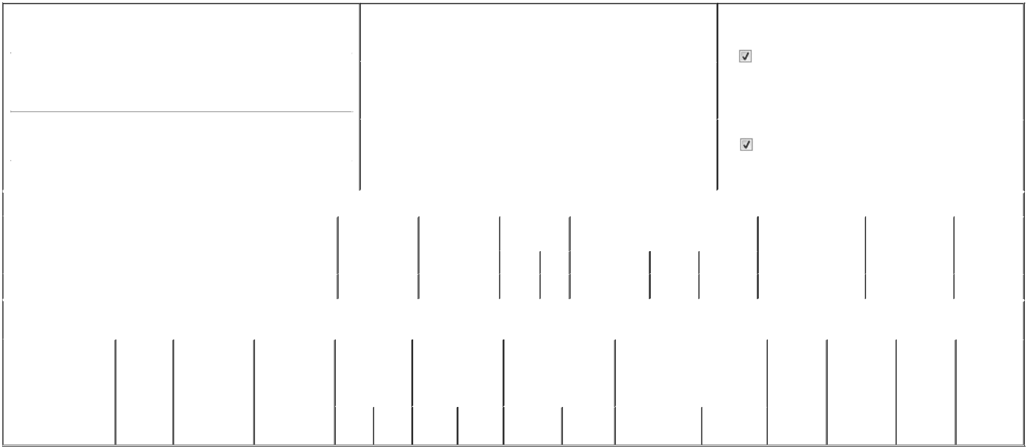

1. Name and Address of Reporting Person* |  |  |  |  | 2. |  |  | Issuer Name and Ticker or Trading Symbol
 | CAGNONI PABLO J |  |  |  |  |  | INCYTE CORP [ INCY ]
 | (Last) | (First) |  | (Middle)
 | (Last) |  |  | (Middle) | 3. |  |  | Date of Earliest Transaction (Month/Day/Year)
 | 1801 AUGUSTINE CUT-OFF |  |  |  | 05/06/2026

- Relationship of Reporting Person(s) to Issuer (Check all applicable)
Director | 10% Owner
Officer (give title | Other (specify below)
below) | Other (specify below)

President, Global Head of R&D

 | (Street) |  |  |  |  |  |  | 4. If Amendment, Date of Original Filed (Month/Day/Year) |  |  |  |  |  |  |  | 6. Individual or Joint/Group Filing (Check Applicable Line)
 |  | WILMINGTON | DE | 19083 |  | 04/17/2026 |  |  |  |  |  |  |  |  |  |  |  | Form filed by One Reporting Person
 |  |  |  |  |  |  |  |  |  |  |  |  |  |  |  |  |  | Form filed by More than One Reporting Person
 |  | (City) | (State) | (Zip)
 |  |  |  |  | Table I - Non-Derivative Securities Acquired, Disposed of, or Beneficially Owned
 | 1. Title of Security (Instr. 3) |  |  |  |  | 2. Transaction |  |  | 2A. Deemed |  | 3. Transaction |  | 4. Securities Acquired (A) or Disposed Of |  |  |  | 5. Amount of Securities |  |  | 6. Ownership |  | 7. Nature of
 |  |  |  |  |  | Date |  |  | Execution Date, |  | Code (Instr. 8) (D) (Instr. 3, 4 and 5) |  |  |  |  |  | Beneficially Owned |  |  | Form: Direct (D) or |  | Indirect
 |  |  |  |  |  | (Month/Day/Year) |  |  | if any |  |  |  |  |  |  |  | Following Reported |  |  | Indirect (I) (Instr. 4) |  | Beneficial
 |  |  |  |  |  |  |  |  | (Month/Day/Year) |  | Code | V | Amount |  | (A) or (D) | Price | Transaction(s) (Instr. 3 |  |  |  |  | Ownership
 |  |  |  |  |  |  |  |  |  |  | Code | V | Amount |  | (A) or (D) | Price | and 4) |  |  |  |  | (Instr. 4)
 | Common Stock |  |  |  |  | 05/06/2026 |  |  |  |  | A |  | 31,517⁽¹⁾⁽²⁾ |  | A | $0 | 266,317⁽³⁾ |  |  |  | D
 |  |  |  |  | Table II - Derivative Securities Acquired, Disposed of, or Beneficially Owned
 |  |  |  |  |  | (e.g., puts, calls, warrants, options, convertible securities)
 | 1. Title of Derivative |  | 2. | 3. Transaction | 3A. Deemed | 4. Transaction |  |  | 5. Number of |  | 6. Date Exercisable and |  |  | 7. Title and Amount of Securities |  |  |  | 8. Price of | 9. Number of |  | 10. | 11. Nature of
 | Security (Instr. 3) |  | Conversion | Date | Execution Date, | Code (Instr. 8) |  |  | Derivative |  | Expiration Date |  |  | Underlying Derivative Security |  |  |  | Derivative | derivative |  | Ownership | Indirect
 |  |  | or Exercise | (Month/Day/Year) | if any |  |  |  | Securities Acquired |  | (Month/Day/Year) |  |  | (Instr. 3 and 4) |  |  |  | Security | Securities |  | Form: | Beneficial
 |  |  | Price of |  | (Month/Day/Year) |  |  |  | (A) or Disposed of |  |  |  |  |  |  |  |  | (Instr. 5) | Beneficially |  | Direct (D) or | Ownership
 |  |  | Derivative |  |  |  |  |  | (D) (Instr. 3, 4 and |  |  |  |  |  |  |  |  |  | Owned |  | Indirect (I) | (Instr. 4)
 |  |  | Security |  |  |  |  |  | 5) |  |  |  |  |  |  |  |  |  | Following |  | (Instr. 4)
 |  |  |  |  |  |  |  |  |  |  |  |  |  |  |  |  |  |  | Reported
 |  |  |  |  |  |  |  |  |  |  |  |  |  |  |  | Amount or |  |  | Transaction(s)
 |  |  |  |  |  |  |  |  |  |  | Date |  | Expiration |  |  | Number of |  |  | (Instr. 4)
 |  |  |  |  |  | Code V |  |  | (A) | (D) | Exercisable |  | Date | Title |  | Shares

Explanation of Responses:

- Represents the shares of common stock underlying performance shares earned upon the achievement of performance criteria determined to be satisfied on May 6, 2026. The earned shares will vest on the third anniversary of the July 14, 2023 grant date, subject to the Reporting Person's continued service with the Issuer. Each performance share represents the right to receive one or more shares of common stock based on, and subject to, specified development, revenue and market-based (relative total shareholder returns compared to the Nasdaq Biotechnology Index) performance goals determined by the Issuer's Compensation Committee in January 2023 as set forth in the Performance Share Award Agreement. The number of shares of common stock that the Reporting Person is entitled to receive over the three-year performance period ranges from 0% to 150% of the number of performance shares awarded.

- This Form 4/A amends the original Form 4, filed on April 17, 2026, to reflect the Compensation Committee's determination on May 6, 2026 relating to the achievement of the performance criteria, which superseded the Compensation Committee's initial determination on April 15, 2026.

- Including this certification of performance shares, this includes an aggregate of 261,178 shares of common stock issuable pursuant to previously reported restricted stock units and earned performance shares that have not vested.

Remarks:

 | /s/ Elizabeth Feeney, Attorney-In-Fact |  |  | 05/20/2026
 | ** Signature of Reporting Person |  | Date
Reminder: Report on a separate line for each class of securities beneficially owned directly or indirectly.
* If the form is filed by more than one reporting person, see Instruction 4 (b)(v).
** Intentional misstatements or omissions of facts constitute Federal Criminal Violations See 18 U.S.C. 1001 and 15 U.S.C. 78ff(a).
Note: File three copies of this Form, one of which must be manually signed. If space is insufficient, see Instruction 6 for procedure.
Persons who respond to the collection of information contained in this form are not required to respond unless the form displays a currently valid OMB Number.



